Day 375 — Linked List + Stack + Queue
🔹 Task Title / Requirement
Revise three fundamental data structures in C++: Linked Lists, Stacks, and Queues. Focus on understanding how they work, implementing their core operations, and knowing when to use each one.
By the end of this revision, you should be able to:
- Implement singly, doubly, and circular linked lists.
- Perform insertion, deletion, traversal, and reversal.
- Implement stacks and queues using arrays and linked lists.
- Understand circular queues and their front/rear management.
- Implement a queue using two stacks.
- Analyze the time and space complexity of common operations.
1. Linked List
A linked list is a linear data structure made of nodes. Each node stores data and one or more pointers connecting it to other nodes.
Unlike an array, linked-list nodes do not need to occupy consecutive memory locations.
Singly linked list
10
data
20
data
30
data
NULL
Each node points to the next node. The final node points to NULL.
1.1 Types of linked lists
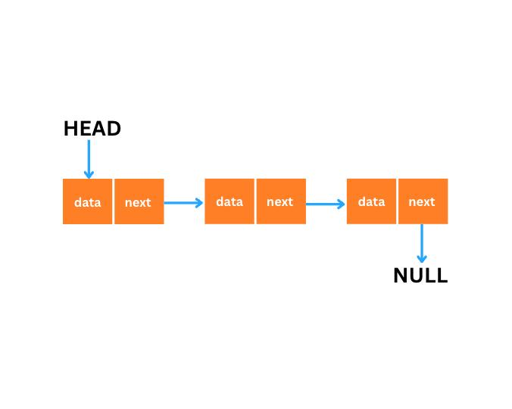
1. Singly linked list
Each node contains data and a next pointer.
Traversal is possible only in the forward direction.
Example: 10 → 20 → 30 → NULL
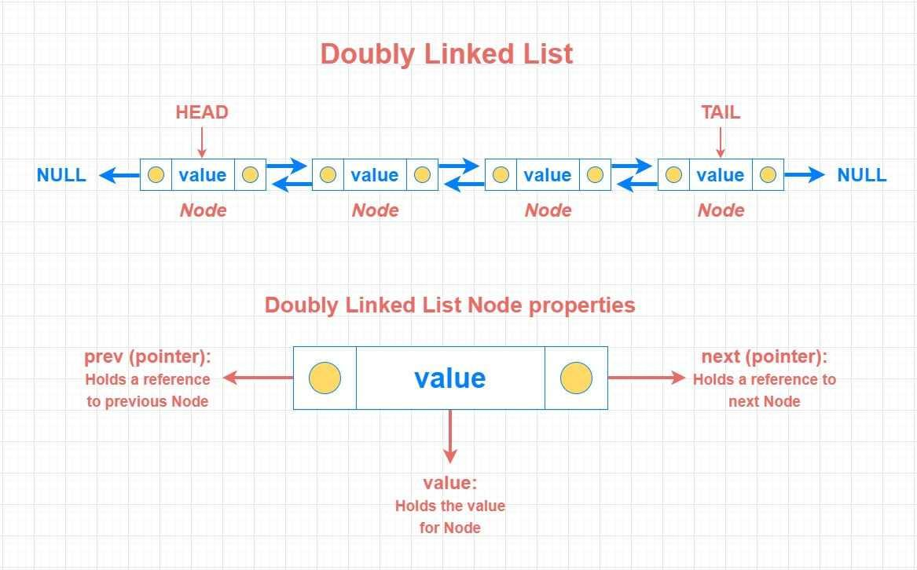
2. Doubly linked list
Each node contains prev, data, and next.
Traversal is possible in both directions.
Example: NULL ← 10 ⇄ 20 ⇄ 30 → NULL
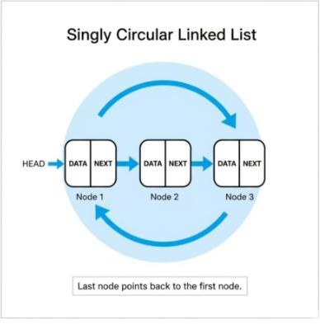
3. Circular linked list
The last node points back to the first node instead of NULL.
Example: 10 → 20 → 30 ↺ 10
1.2 Node structure in C++
Singly linked list node
struct Node {
int data;
Node* next;

Node(int value) {
data = value;
next = nullptr;
}
};
Doubly linked list node
struct Node {
int data;
Node* prev;
Node* next;

Node(int value) {
data = value;
prev = nullptr;
next = nullptr;
}
};
In C++, Node* is a pointer to a node. nullptr means the pointer currently points to no object.
1.3 Core linked-list operations
Operation | Singly linked list | Doubly linked list
Insert at beginning | O(1) | O(1)
Insert at end | O(n), without tail | O(1), with tail
Delete from beginning | O(1) | O(1)
Search by value | O(n) | O(n)
Access the node at index i | O(n) | O(n)
Reverse the list | O(n) | O(n)
These complexities assume a standard implementation; the exact insertion/deletion cost also depends on whether you already have the relevant node or predecessor.
A. Insertion at the beginning
Suppose the current list is:
20 → 30 → NULL
To insert 10:
- Create a new node containing 10.
- Make its next point to the current head.
- Update head to the new node.
Node* newNode = new Node(10);
newNode->next = head;
head = newNode;
Result: 10 → 20 → 30 → NULL
B. Insertion at the end
- Create a new node.
- If the list is empty, make it the head.
- Otherwise, traverse to the last node.
- Link the last node to the new node.
Node* newNode = new Node(40);

if (head == nullptr) {
head = newNode;
} else {
Node* temp = head;

while (temp->next != nullptr) {
temp = temp->next;
}

temp->next = newNode;
}
C. Deletion from the beginning
if (head != nullptr) {
Node* temp = head;
head = head->next;
delete temp;
}
Important: Update head before deleting the old first node. Otherwise, you may lose access to the rest of the list.
D. Reversal of a singly linked list
Original: 10 → 20 → 30 → NULL
Reversed: 30 → 20 → 10 → NULL
Use three pointers:
- prev: previously processed node.
- curr: current node.
- nextNode: saves the next node before changing the link.
Step-by-step reversal
Initial list: 10 → 20 → 30 → NULL
Step 1
Reverse the link from 10 to NULL.
10 → NULL
Step 2
Make 20 point to 10.
20 → 10 → NULL
Step 3
Make 30 point to 20.
30 → 20 → 10 → NULL
Node* reverseList(Node* head) {
Node* prev = nullptr;
Node* curr = head;

while (curr != nullptr) {
Node* nextNode = curr->next;
curr->next = prev;
prev = curr;
curr = nextNode;
}

return prev;
}
Complexity: Time O(n), auxiliary space O(1).
Remember the order: save next → reverse link → move prev → move curr. If you reverse the link before saving nextNode, you can lose the remaining list.
1.4 Complete singly linked list implementation
This program includes insertion at the beginning and end, deletion by value, searching, displaying, and reversing.

#include <iostream>
using namespace std;

class SinglyLinkedList {
private:
struct Node {
int data;
Node* next;

Node(int value) : data(value), next(nullptr) {}
};

Node* head;

public:
SinglyLinkedList() : head(nullptr) {}

~SinglyLinkedList() {
while (head != nullptr) {
Node* temp = head;
head = head->next;
delete temp;
}
}

void insertFront(int value) {
Node* node = new Node(value);
node->next = head;
head = node;
}

void insertEnd(int value) {
Node* node = new Node(value);

if (head == nullptr) {
head = node;
return;
}

Node* temp = head;
while (temp->next != nullptr) {
temp = temp->next;
}
temp->next = node;
}

bool deleteValue(int value) {
if (head == nullptr) {
return false;
}

if (head->data == value) {
Node* temp = head;
head = head->next;
delete temp;
return true;
}

Node* temp = head;
while (temp->next != nullptr &&
temp->next->data != value) {
temp = temp->next;
}

if (temp->next == nullptr) {
return false;
}

Node* victim = temp->next;
temp->next = victim->next;
delete victim;
return true;
}

bool search(int value) const {
Node* temp = head;

while (temp != nullptr) {
if (temp->data == value) {
return true;
}
temp = temp->next;
}
return false;
}

void reverse() {
Node* prev = nullptr;
Node* curr = head;

while (curr != nullptr) {
Node* nextNode = curr->next;
curr->next = prev;
prev = curr;
curr = nextNode;
}

head = prev;
}

void display() const {
Node* temp = head;

while (temp != nullptr) {
cout << temp->data << " -> ";
temp = temp->next;
}
cout << "NULL\n";
}
};

int main() {
SinglyLinkedList list;

list.insertEnd(10);
list.insertEnd(20);
list.insertEnd(30);

cout << "Original list: ";
list.display();

list.insertFront(5);
cout << "After insertion: ";
list.display();

list.deleteValue(20);
cout << "After deletion: ";
list.display();

cout << "Search 30: "
<< (list.search(30) ? "Found" : "Not found")
<< '\n';

list.reverse();
cout << "Reversed list: ";
list.display();

return 0;
}
The destructor frees the dynamically allocated nodes when the list object is destroyed, preventing memory leaks in this example.
1.5 Doubly linked list insertion and deletion
In a doubly linked list, changing links requires updating both next and prev.
For example, insert 20 between 10 and 30:
Before: 10 ⇄ 30
After: 10 ⇄ 20 ⇄ 30
newNode->prev = first;
newNode->next = first->next;

first->next->prev = newNode;
first->next = newNode;
This example assumes first exists and has a next node. At the head or tail, handle the boundary separately.
To delete a node curr from a doubly linked list:
if (curr->prev != nullptr) {
curr->prev->next = curr->next;
} else {
head = curr->next;
}

if (curr->next != nullptr) {
curr->next->prev = curr->prev;
}

delete curr;
This works when curr belongs to the list and head is the head pointer. A tail pointer, if maintained, must also be updated when deleting the last node.
1.6 Circular linked list
In a circular singly linked list, the last node points to head:
10 → 20 → 30 → 10 → ...
A common mistake is using while (temp != nullptr) to traverse it. That condition never becomes false for a nonempty circular list.
Use a do-while loop instead:
void displayCircular(Node* head) {
if (head == nullptr) {
cout << "List is empty\n";
return;
}

Node* temp = head;

do {
cout << temp->data << " ";
temp = temp->next;
} while (temp != head);

cout << '\n';
}
Applications: round-robin CPU scheduling, circular playlists, and turn-based systems.
2. Stack
A stack is a linear data structure that follows LIFO — Last In, First Out.
Stack example
30 — TOP
20
10
Push adds to the top; pop removes from the top.
If you push 10, then 20, then 30, the first value popped is 30.
2.1 Main stack operations
Operation | Purpose | Typical complexity
push(x) | Add an element | O(1)
pop() | Remove the top element | O(1)
top() / peek() | Read the top element | O(1)
empty() | Check whether empty | O(1)
search(x) | Find an element | O(n)
Two common errors:
- Stack overflow: attempting to push onto a full fixed-capacity stack.
- Stack underflow: attempting to pop from an empty stack.
2.2 Stack implementation using an array
#include <iostream>
using namespace std;

class Stack {
private:
static const int CAPACITY = 100;
int arr[CAPACITY];
int topIndex;

public:
Stack() : topIndex(-1) {}

bool empty() const {
return topIndex == -1;
}

bool full() const {
return topIndex == CAPACITY - 1;
}

bool push(int value) {
if (full()) {
cout << "Stack overflow\n";
return false;
}

arr[++topIndex] = value;
return true;
}

bool pop(int& removed) {
if (empty()) {
cout << "Stack underflow\n";
return false;
}

removed = arr[topIndex--];
return true;
}

bool peek(int& value) const {
if (empty()) {
return false;
}

value = arr[topIndex];
return true;
}

void display() const {
for (int i = topIndex; i >= 0; --i) {
cout << arr[i] << '\n';
}
}
};

int main() {
Stack s;
s.push(10);
s.push(20);
s.push(30);

cout << "Stack from top to bottom:\n";
s.display();

int value;
if (s.pop(value)) {
cout << "Popped: " << value << '\n';
}

if (s.peek(value)) {
cout << "Top: " << value << '\n';
}

return 0;
}
Understand topIndex
- Initially topIndex = -1: the stack is empty.
- arr[++topIndex] = value: increment first, then insert.
- removed = arr[topIndex--]: read the current top, then decrement.
This implementation has a fixed capacity of 100 elements. A vector-based stack can grow dynamically, while a linked-list stack allocates nodes as needed.
2.3 Stack using a linked list
Use the head of a singly linked list as the stack top. This allows push and pop at the head in O(1) time.
#include <iostream>
using namespace std;

class LinkedStack {
private:
struct Node {
int data;
Node* next;

Node(int value) : data(value), next(nullptr) {}
};

Node* topNode;

public:
LinkedStack() : topNode(nullptr) {}

~LinkedStack() {
while (topNode != nullptr) {
Node* temp = topNode;
topNode = topNode->next;
delete temp;
}
}

bool empty() const {
return topNode == nullptr;
}

void push(int value) {
Node* node = new Node(value);
node->next = topNode;
topNode = node;
}

bool pop(int& value) {
if (empty()) {
return false;
}

Node* temp = topNode;
value = temp->data;
topNode = topNode->next;
delete temp;
return true;
}

bool peek(int& value) const {
if (empty()) {
return false;
}

value = topNode->data;
return true;
}
};

int main() {
LinkedStack s;
s.push(10);
s.push(20);
s.push(30);

int value;

while (s.pop(value)) {
cout << value << " ";
}
cout << '\n';

return 0;
}
Output: 30 20 10
Applications of stacks: function calls and recursion, undo operations, expression evaluation, parentheses matching, and depth-first search (DFS).
3. Queue
A queue is a linear data structure that follows FIFO — First In, First Out.
The element inserted first is removed first, just like people standing in a line.
Queue example
10
Front
20
30
Rear
Dequeue ←
→ Enqueue
3.1 Main queue operations
Operation | Purpose | Typical complexity
enqueue(x) | Insert at rear | O(1)
dequeue() | Remove from front | O(1)
front() | Read first element | O(1)
empty() | Check whether empty | O(1)
A simple array queue needs careful index management. A linked-list queue with both front and rear pointers supports enqueue and dequeue in O(1).
3.2 Queue implementation using a linked list
#include <iostream>
using namespace std;

class LinkedQueue {
private:
struct Node {
int data;
Node* next;

Node(int value) : data(value), next(nullptr) {}
};

Node* frontNode;
Node* rearNode;

public:
LinkedQueue() : frontNode(nullptr), rearNode(nullptr) {}

~LinkedQueue() {
int value;
while (dequeue(value)) {
// Remove and free every node.
}
}

bool empty() const {
return frontNode == nullptr;
}

void enqueue(int value) {
Node* node = new Node(value);

if (empty()) {
frontNode = rearNode = node;
return;
}

rearNode->next = node;
rearNode = node;
}

bool dequeue(int& value) {
if (empty()) {
return false;
}

Node* temp = frontNode;
value = temp->data;
frontNode = frontNode->next;
delete temp;

if (frontNode == nullptr) {
rearNode = nullptr;
}

return true;
}

bool front(int& value) const {
if (empty()) {
return false;
}

value = frontNode->data;
return true;
}

void display() const {
Node* temp = frontNode;

while (temp != nullptr) {
cout << temp->data << " ";
temp = temp->next;
}
cout << '\n';
}
};

int main() {
LinkedQueue q;
q.enqueue(10);
q.enqueue(20);
q.enqueue(30);

cout << "Queue: ";
q.display();

int value;
if (q.dequeue(value)) {
cout << "Removed: " << value << '\n';
}

cout << "Remaining: ";
q.display();

return 0;
}
Output:
Queue: 10 20 30
Removed: 10
Remaining: 20 30
Important edge case: when the last element is removed, both frontNode and rearNode must become nullptr. Otherwise, rearNode would point to deleted memory.
4. Circular Queue
A circular queue treats the end of an array as connected to its beginning. This allows the queue to reuse spaces left empty by dequeue operations.
The problem with a linear array queue
Suppose an array has five positions:
- Enqueue 10, 20, 30, 40, 50.
- Dequeue 10 and 20.
- The first two positions are now empty, but rear is still at the last array position.
A simple linear queue may incorrectly report that it is full, even though two positions are unused.
Visualize the difference
A0B1C2—3—4—5FrontRearWrap to index 0
Circular queue: 3 items, front 0 → rear 2.
LinearCircular
Enqueue DDequeue AReset
Give feedback
In circular mode, indices wrap around to the start of the array.
For an array of capacity \(N\):
\[ \text{next index}=(\text{current index}+1)\bmod N \]
For capacity 5, the next index after 4 is:
\[ (4+1)\bmod 5=0 \]
4.1 Circular queue implementation using an array
This version tracks the number of stored elements (count), so the empty and full conditions are unambiguous.

#include <iostream>
using namespace std;

class CircularQueue {
private:
static const int CAPACITY = 5;
int arr[CAPACITY];
int frontIndex;
int rearIndex;
int count;

public:
CircularQueue()
: frontIndex(0), rearIndex(-1), count(0) {}

bool empty() const {
return count == 0;
}

bool full() const {
return count == CAPACITY;
}

bool enqueue(int value) {
if (full()) {
cout << "Queue is full\n";
return false;
}

rearIndex = (rearIndex + 1) % CAPACITY;
arr[rearIndex] = value;
++count;

return true;
}

bool dequeue(int& value) {
if (empty()) {
cout << "Queue is empty\n";
return false;
}

value = arr[frontIndex];
frontIndex = (frontIndex + 1) % CAPACITY;
--count;

return true;
}

bool front(int& value) const {
if (empty()) {
return false;
}

value = arr[frontIndex];
return true;
}

void display() const {
for (int i = 0; i < count; ++i) {
int index = (frontIndex + i) % CAPACITY;
cout << arr[index] << " ";
}
cout << '\n';
}
};

int main() {
CircularQueue q;

q.enqueue(10);
q.enqueue(20);
q.enqueue(30);
q.enqueue(40);
q.enqueue(50);

cout << "Full queue: ";
q.display();

int value;
q.dequeue(value);
q.dequeue(value);

q.enqueue(60);
q.enqueue(70);

cout << "After reuse: ";
q.display();

return 0;
}
Output:
Full queue: 10 20 30 40 50
After reuse: 30 40 50 60 70
Circular queue conditions
Condition | Expression
Empty | count == 0
Full | count == CAPACITY
Advance rear | (rearIndex + 1) % CAPACITY
Advance front | (frontIndex + 1) % CAPACITY
Both enqueue and dequeue take O(1) time, and the array uses O(N) space.
5. Queue using two stacks
This is a classic interview problem. A stack uses LIFO, but a queue requires FIFO. We can build a queue by using two stacks, usually named inStack and outStack.
- inStack: stores newly enqueued elements.
- outStack: supplies elements for dequeue operations.
How it works
Suppose we enqueue 10, 20, and 30.
Step 1 — Enqueue
inStack
30 — TOP
20
10
outStack
Empty
New elements are pushed onto inStack.
Step 2 — Transfer when dequeue is needed
inStack
Empty
outStack
10 — TOP
20
30
Popping all elements from inStack and pushing them onto outStack reverses their order.
Now 10 is at the top of outStack, so it is dequeued first, preserving FIFO order.
5.1 Complete C++ implementation

#include <iostream>
#include <stack>
using namespace std;

class QueueUsingStacks {
private:
stack<int> inStack;
stack<int> outStack;

void transferIfNeeded() {
if (outStack.empty()) {
while (!inStack.empty()) {
outStack.push(inStack.top());
inStack.pop();
}
}
}

public:
void enqueue(int value) {
inStack.push(value);
}

bool dequeue(int& value) {
transferIfNeeded();

if (outStack.empty()) {
return false;
}

value = outStack.top();
outStack.pop();
return true;
}

bool front(int& value) {
transferIfNeeded();

if (outStack.empty()) {
return false;
}

value = outStack.top();
return true;
}

bool empty() const {
return inStack.empty() && outStack.empty();
}
};

int main() {
QueueUsingStacks q;

q.enqueue(10);
q.enqueue(20);
q.enqueue(30);

int value;

if (q.dequeue(value)) {
cout << "Removed: " << value << '\n';
}

q.enqueue(40);

while (q.dequeue(value)) {
cout << "Removed: " << value << '\n';
}

return 0;
}
Output:
Removed: 10
Removed: 20
Removed: 30
Removed: 40
Complexity of a queue using two stacks
Operation | Complexity
Enqueue | O(1)
Dequeue | O(1) amortized, O(n) worst case
Front | O(1) amortized, O(n) worst case
Space | O(n)
Why amortized O(1)? Each element is pushed into inStack once, transferred to outStack at most once, and popped from outStack once. Across many operations, the total work is linear in the number of elements processed.
6. Final comparison sheet
Linked List vs Stack vs Queue
Feature | Linked List | Stack | Queue
Main principle | Nodes connected by pointers | LIFO | FIFO
Insertion | Depends on position | Top | Rear
Deletion | Depends on position | Top | Front
Main pointers/indices | head, optional tail | top | front, rear
Common applications | Dynamic collections | Undo, recursion, DFS | Scheduling, buffering, BFS
Important complexities to memorize
Data structure / operation | Time complexity
Singly linked list: insert at head | O(1)
Singly linked list: search | O(n)
Singly linked list: reverse | O(n)
Doubly linked list: delete a known node | O(1)
Array stack: push / pop | O(1)
Linked-list stack: push / pop | O(1)
Linked-list queue: enqueue / dequeue | O(1)
Circular queue: enqueue / dequeue | O(1)
Queue using two stacks: enqueue | O(1)
Queue using two stacks: dequeue | O(1) amortized
7. Practice tasks — Build Yourself
Day 375 checklist
0 of 6 completed
Singly linked list
Add insertion at a specific position and deletion by position.
Doubly linked list
Implement insertion at both ends, deletion, and forward/backward traversal.
Circular linked list
Implement insertion at the end, deletion by value, and safe traversal.
Stack
Implement a stack using an array, then solve balanced-parentheses checking.
Circular queue
Simulate enqueue/dequeue operations and test wraparound and full/empty conditions.
Queue using two stacks
Implement enqueue, dequeue, front, and empty without using a queue internally.
8. Quick revision quiz
1. Which linked list allows traversal in both directions?
Singly linked list
Doubly linked list
Singly circular list
2. What is the initial top index of an empty array stack?
0
1
-1
3. Which principle does a queue follow?
LIFO
FIFO
Random order
4. Why use modulo in a circular queue?
To sort elements
To wrap indices around
To delete all elements
5. In a queue built from two stacks, when should elements transfer to outStack?
On every enqueue
Whenever outStack is empty and an element is needed
Only when both stacks are full
Check answers
Final revision target: Be able to write the linked-list reversal algorithm from memory, explain stack overflow and queue underflow, implement circular-queue wraparound, and explain why two stacks can implement a FIFO queue.

